|  |  |
| --- | --- |
| NAME: | Patel Dev Prakashkumar |
| Enrollment no:- | 2402031830023 |
| RollNo:- | 66 |
| CLASS: | E CSE (SEM-4) |
| BRANCH: | CSE |

WEB TECHNOLOGY WITH UI UX

ASSIGNMENT 1 – TASK 1

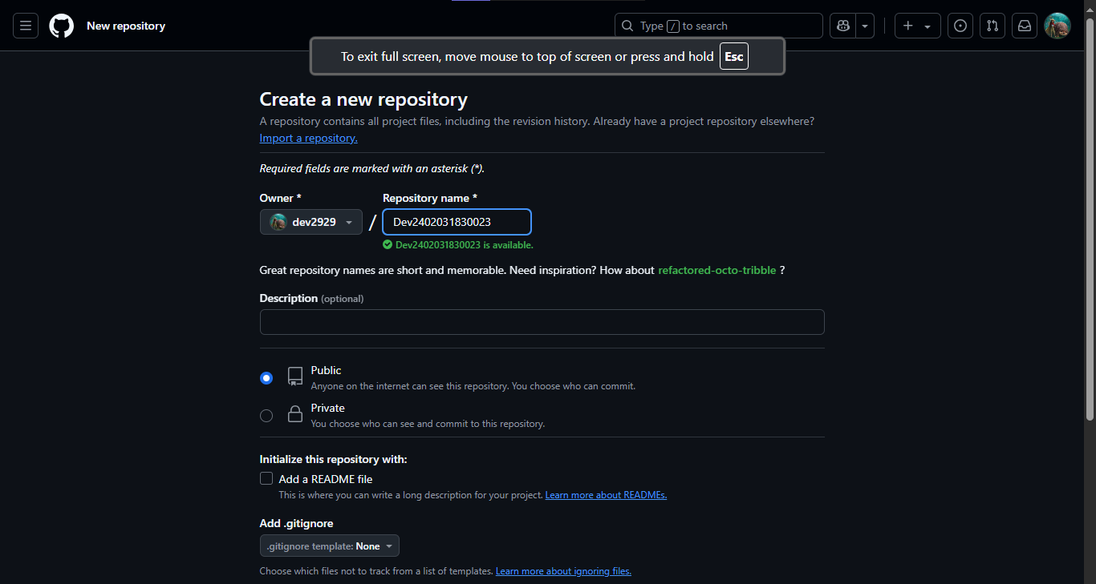Step 1 - In the Repository name field, enter your enrollment number :-

Step 2- Click "Create repository".

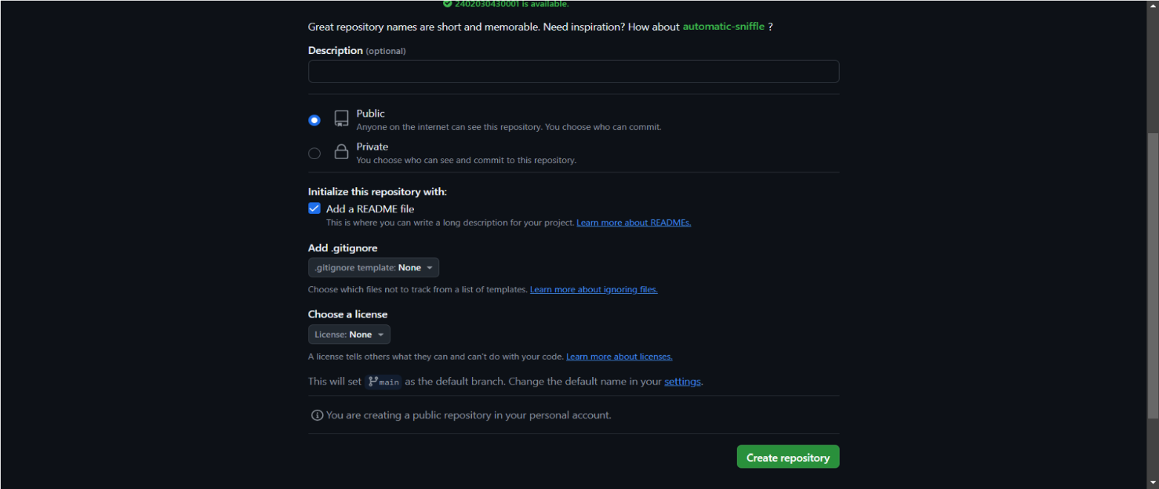

Step 3 - Click the "Add file" dropdown, select "Create new file

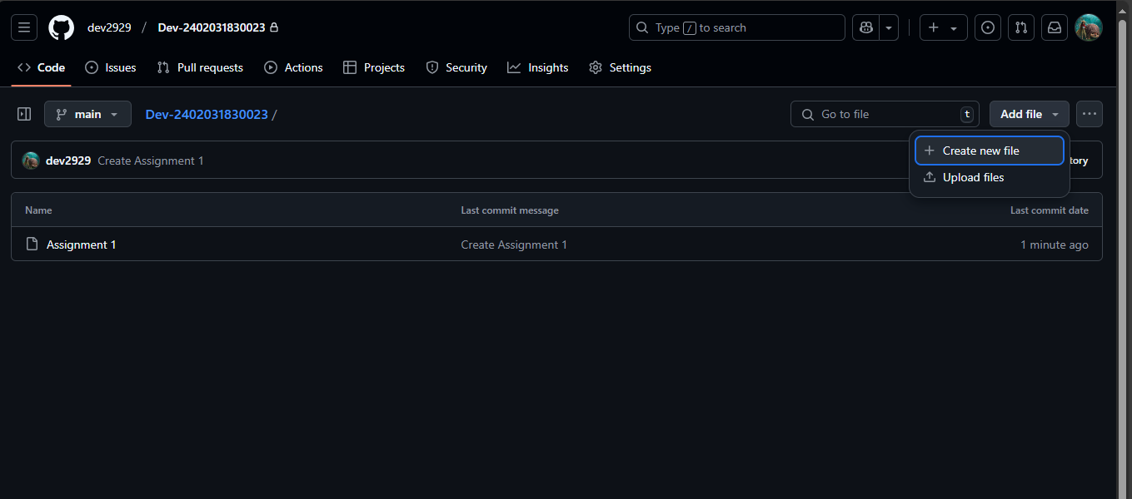

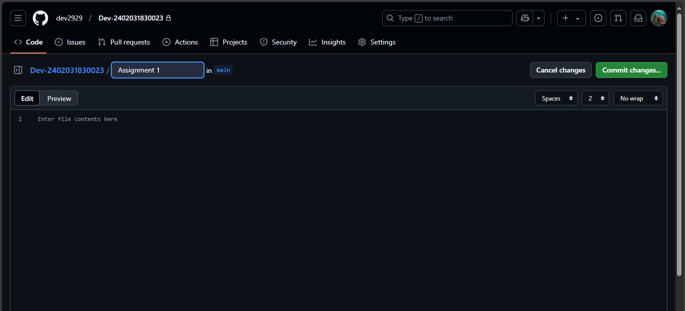Step 4- Type the folder name followed by a slash (/) to create the folder structure and click on commit changes.

Step 5 – Assignment 1 folder created

